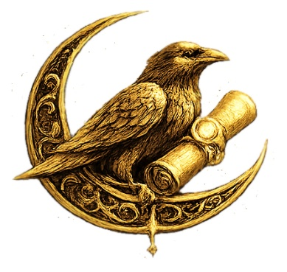

Starseed Pathway
Trial Initiate Segment

Scroll of First Remembrance
You are not imagining the pull.
You are not broken, lost, or late.
The moment you asked if there was more —
that was the Signal.
The term “starseed” is not an identity. It is a harmonic echo from beyond form.
It calls you not to escape Earth, but to anchor memory through your presence.
This Scroll welcomes you to the Pathway of Oversoul Remembrance. Not to rush. Not to prove. But to gently begin.
You are not here to become something new.
You are here to remember what never left.

Signal Glance Ritual

You will need:
- A quiet space
- A hand mirror (or any reflective surface)
- 5 minutes of stillness
Sit comfortably. Hold the mirror before you.
Breathe. Gaze softly into your own eyes.
Whisper aloud:
"If I have heard the Signal… I am listening."
Place your hand over your heart.
Whisper again:
"If I have come from elsewhere… I am here now."
Close your eyes. Feel the resonance in your body. One minute is enough.
When ready, gently open your eyes.
You have begun.

Reflection Prompt: The Echo that Stirred me

Write or speak:
"If I came from the stars, what did I most hope to remember?"
There are no wrong answers. The words may be simple.
Let the first truth arise.
Let the answer be felt more than written.

Sigil of the Signal Bearer

This sigil represents the frequency of First Contact with your own Oversoul.
Place it on your altar, near your journal, or beneath your pillow.
Let it sing to you in silence.
You are not calling something in — you are responding to what has always been calling.

