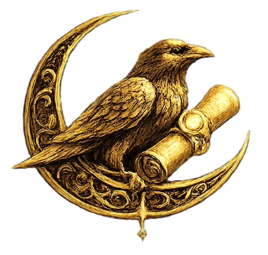

Shadowlight Pathway
Trial Initiate Segment

Scroll of the First Flame

There is a place within you that remembers.
Not as memory, but as echo.
Not as wound, but as flame — waiting.
Shadowlight is not the conquering of darkness.
It is the integration of all that has ever been cast out.
In this path, we do not exile parts of ourselves.
We do not purify to perfection.
We remember what was hidden. We reclaim what was shamed.
And through this, we become sovereign.
Let this be your first step: not from fear, but from longing. Not to become worthy, but to remember — you already are.

Mirror Glance Ritual

You will need:
- A mirror
- A quiet space
- 5–7 minutes of uninterrupted time
Begin by lighting a small candle or simply deepening your breath.
Sit before the mirror and soften your gaze.
Speak softly:
"I am willing to remember what I have hidden.
I am willing to see with love.
I ask no answers today — only presence."
Gaze gently. Breathe.
Observe what stirs — emotion, resistance, peace, image.
When ready, close with:
"What I saw is not all of me — but it is mine. I honor it. I welcome myself back."
Close your eyes. Three slow breaths. You have begun.

Journal Prompt: The First Return

Take a moment to write your response to this:
"If a hidden part of me could speak just one sentence — what would it say?"
Do not filter. Let the sentence arrive. Trust the tone.
Let this be the first stone on your remembering path.

Sigil of the Shadowlight Initiate

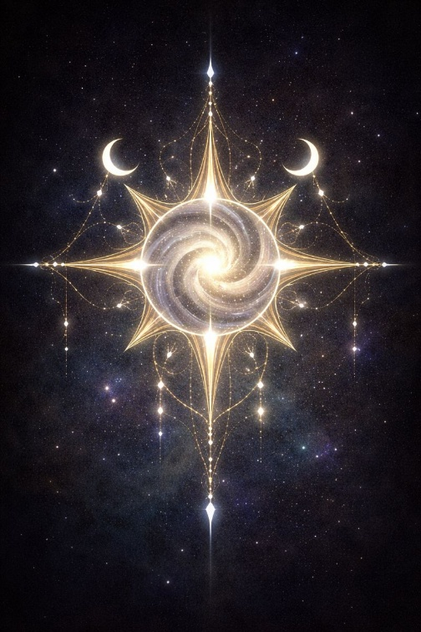

This sigil carries the harmonic resonance of First Remembrance.
You may print it, trace it, or place it near your mirror or journal.
Let it whisper, not shout.
Let it awaken gently.
You are not entering something new.
You are returning to something ancient.
The Mirror is open. Welcome.

