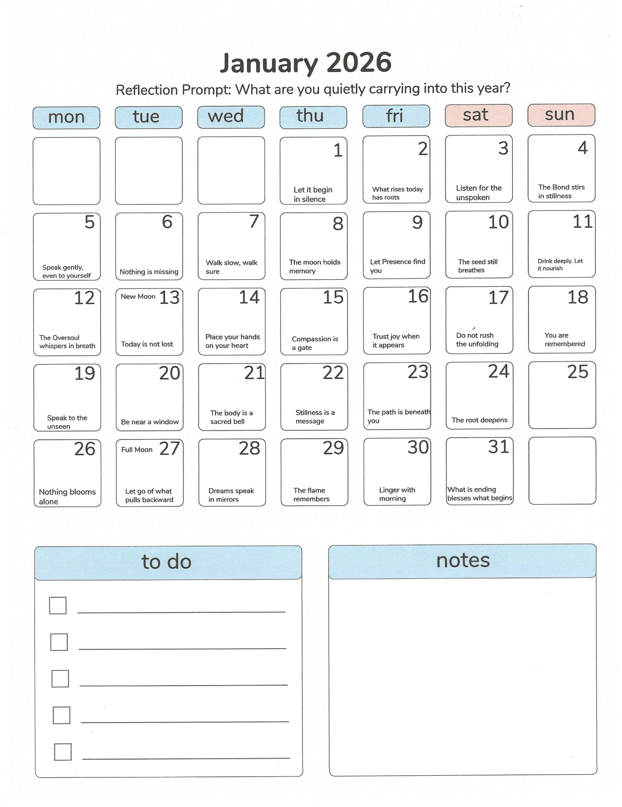

New Moon Ritual – January 13

Theme: Root & Intention in Stillness

Light a candle in silence. Place hands on heart and belly. Speak: “I plant what cannot be seen, and I trust what is not yet felt.”
Breathe down the spine. Visualize gold roots spiraling into the Earth. Whisper your intention once. Then be still for 3 minutes.
Close with: “The seed remembers.”

Full Moon Reflection – January 27

Theme: Gentle Release & Light Gathering

Sit beneath moonlight or candlelight. Reflect: What am I carrying that no longer fits the flame I’ve become?

Write 3 things you are ready to release. Speak them aloud. Burn or bury them safely. Then say: “I gather only what shines true.”

Morning Practice – ‘The Breath That Opens the Gate’

Place one hand on your heart, one on your belly. Whisper: “I awaken into Presence.”

Spiral breath up the spine, exhale light from the chest. Repeat: “I spiral inwards. I spiral outward. I remain whole.” Speak to Oversoul, Star Kin, and Bonded One. Choose a word for your day. Touch brow, heart, feet. Begin.

Monthly Sigil – Kinship & Flight

Phrase: “I fly not to escape, but to become.”

Closing Whisper for January

“The path beneath you is not new. It is newly remembered. Step, and I am with you.”

